Phase 2 semester project CS221. Syed Ali Raza Gardezi 2016474

Ubaid ur Rehman 2016506

Muhammad Saad 2015302

* First, we took the threshold density and periphery from the user as an input.
* File was read and the total number of unique nodes were counted.
* Using the data from the file(“fraser1.txt”) we made the adjacency matrix(graph).

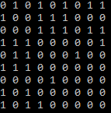

* Degree of the nodes was found by counting the number of edges of each node. If the degree of all the nodes is zero the program stops.
* Adjacency matrix was squared to calculate the weight of the edges and the weight of the nodes was calculated by reading the complete row and taking sum. 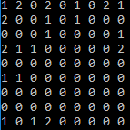 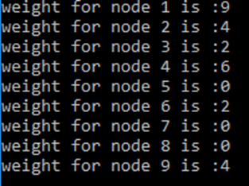
* After that we sorted the nodes using their weight and the node with the highest weight was used to form the cluster.
* Forming txt files for the cluster.
* Then we sorted the neighbours in terms of the sum of weights of the edges between a neighbour and a cluster. The conditions of density and periphery were repeatedly checked before adding the neighbours to the cluster.
* Removing the cluster from the graph. (adjacency matrix).
* Repeating m^2 and every other procedure to check whether any more clusters form. If there are any more clusters that satisfy the conditions more txt files form.
* Checking if the degree of all the nodes is zero. No more clusters can be formed.
* If we enter the threshold density 0.700 the number of nodes in the first cluster are 5 and the number of clusters formed are 3.
* But if take threshold density .701 the number of nodes in first cluster change to 4 and the number of clusters changes to 4.
* The outputs are shown in the following examples

 

Threshold Density = 0.70 Threshold Density = 0.71